CEL LAB CASE STUDY 1
Market equilibrium price determination
Somin Kachhi - 23BME031

- DESCRIPTION
Model demand and supply curves as nonlinear functions and compute equilibrium price numerically
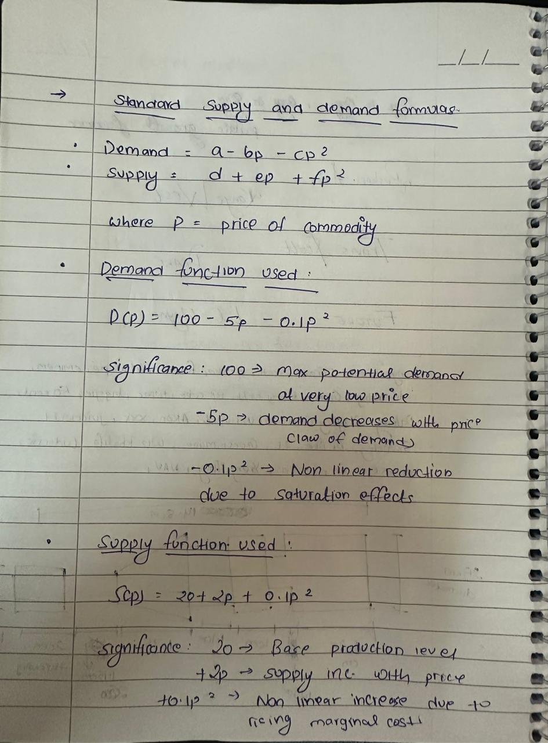
Numerical Method:

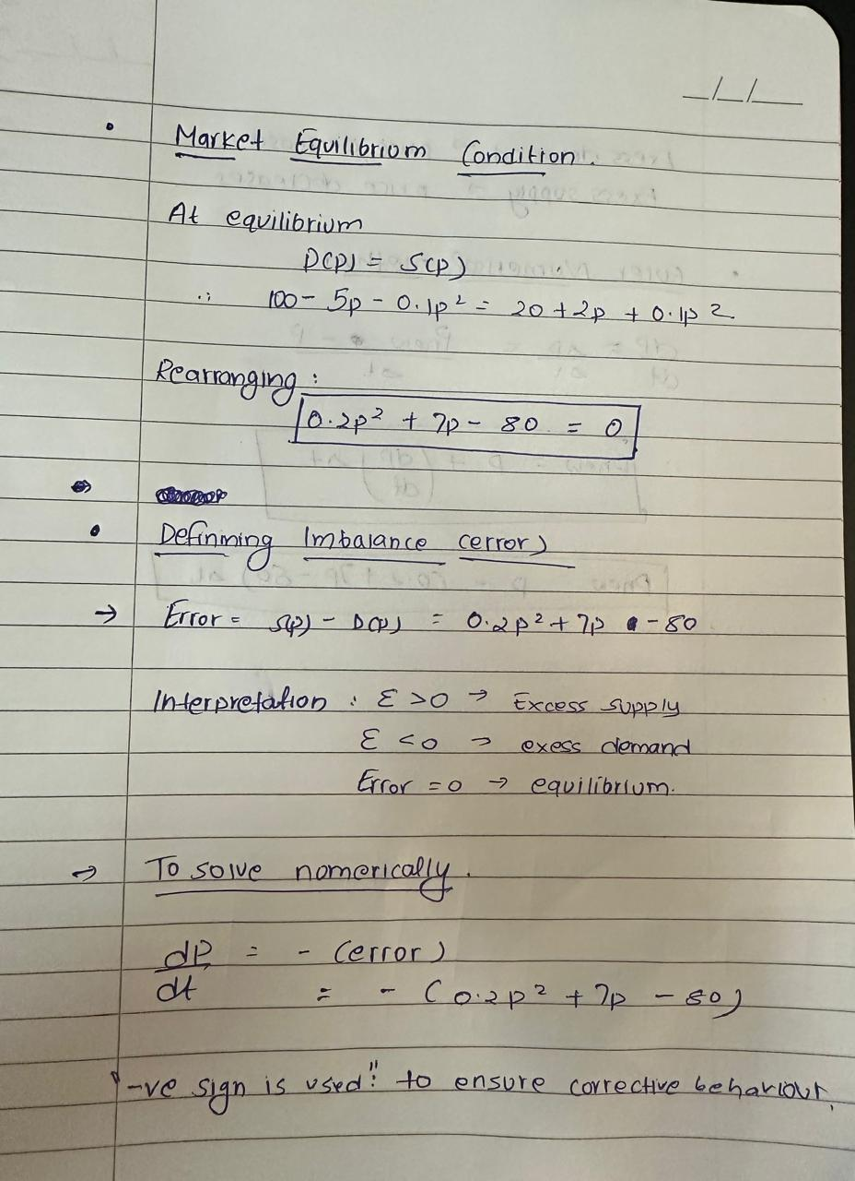
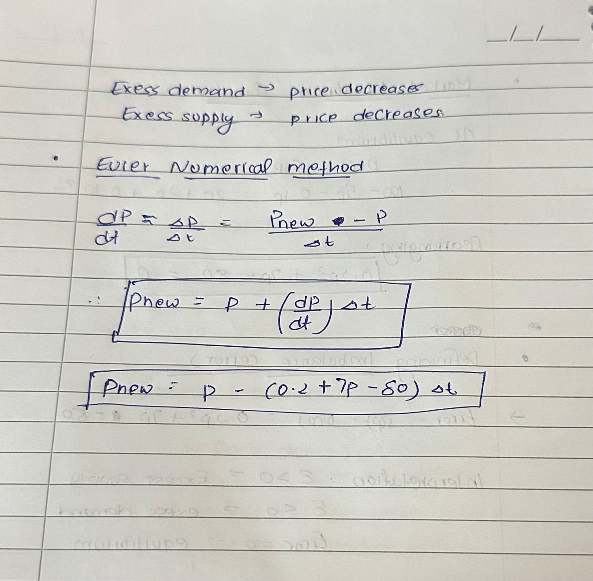

Matlab Code
p = 50;
dt = 0.01;

P = p;

while true
error = 0.2*p^2 + 7*p - 80;
p_new = p - error*dt;

P(end+1) = p_new;

if abs(p_new - p) < 0.001
break;
end

p = p_new;
end

fprintf('Equilibrium price = %.2f units\n', p_new);

p = 0:0.1:20;
D = 100 - 5*p - 0.1*p.^2;
S = 20 + 2*p + 0.1*p.^2;

plot(p,D,'b',p,S,'r')
xlabel('Price')
ylabel('Quantity')
legend('Demand','Supply')
grid on

Output And Graph
